1. import java.util.*;
public class Solution {
private static int[] calculateZ(String s) {
int n = s.length();
int[] Z = new int[n];
int L = 0, R = 0;
for (int i = 1; i < n; i++) {
if (i <= R) {
Z[i] = Math.min(R - i + 1, Z[i - L]);
}
while (i + Z[i] < n && s.charAt(Z[i]) == s.charAt(i + Z[i])) {
Z[i]++;
}
if (i + Z[i] - 1 > R) {
L = i;
R = i + Z[i] - 1;
}
}
return Z;
}
private static long stringSimilarity(String s) {
int[] Z = calculateZ(s);
long sum = s.length(); // full string similarity
for (int z : Z) sum += z;
return sum;
}
public static void main(String[] args) {
Scanner sc = new Scanner(System.in);
int t = sc.nextInt();
while (t-- > 0) {
String s = sc.next();
System.out.println(stringSimilarity(s));
}
sc.close();
}
}
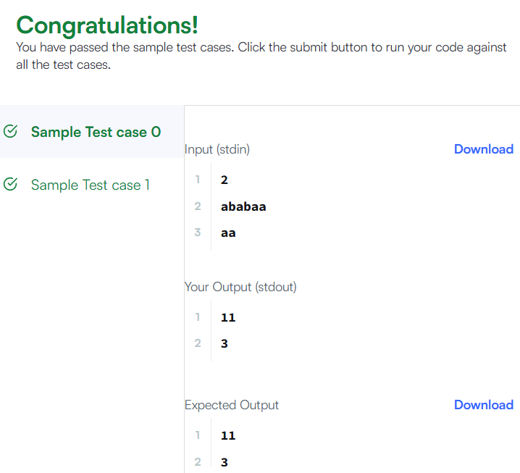

2. import java.util.*;
public class Solution {
public static boolean repeatedSubstringPattern(String s) {
String doubled = s + s;
// Remove first and last character
String trimmed = doubled.substring(1, doubled.length() - 1);
return trimmed.contains(s);
}
public static void main(String[] args) {
Scanner sc = new Scanner(System.in);
String s = sc.next();
System.out.println(repeatedSubstringPattern(s));
sc.close();
}
}
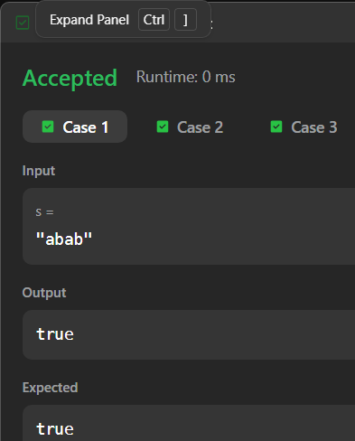

3. import java.util.*;
public class Solution {
public static String twoStrings(String s1, String s2) {
Set<Character> set = new HashSet<>();
for (char c : s1.toCharArray()) {
set.add(c);
}
for (char c : s2.toCharArray()) {
if (set.contains(c)) {
return "YES";
}
}
return "NO";
}
public static void main(String[] args) {
Scanner sc = new Scanner(System.in);
int t = sc.nextInt();
while (t-- > 0) {
String s1 = sc.next();
String s2 = sc.next();
System.out.println(twoStrings(s1, s2));
}
sc.close();
}
}

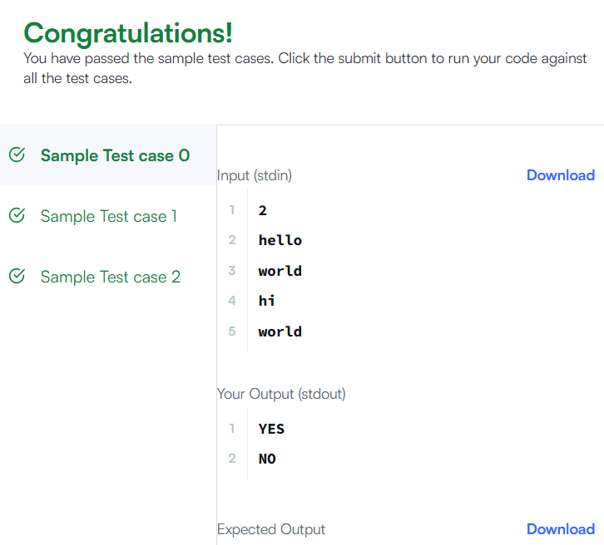

4. import java.util.*;
public class Solution {
public static boolean rotateString(String s, String goal) {
if (s.length() != goal.length()) return false;
String doubled = s + s;
return doubled.contains(goal);
}
public static void main(String[] args) {
Scanner sc = new Scanner(System.in);
String s = sc.next();
String goal = sc.next();
System.out.println(rotateString(s, goal));
sc.close();
}
}
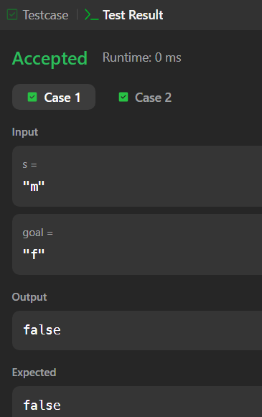

5. import java.util.*;
public class Solution {
public static int marsExploration(String s) {
int changes = 0;
String pattern = "SOS";
for (int i = 0; i < s.length(); i++) {
if (s.charAt(i) != pattern.charAt(i % 3)) {
changes++;
}
}
return changes;
}
public static void main(String[] args) {
Scanner sc = new Scanner(System.in);
String s = sc.next();
System.out.println(marsExploration(s));
sc.close();
}
}
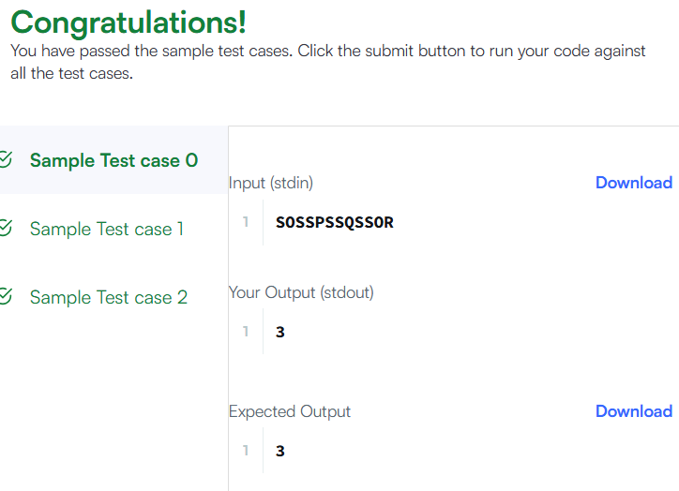

6. import java.util.*;
public class Solution {
public static List<Integer> findAnagrams(String s, String p) {
List<Integer> result = new ArrayList<>();
if (s.length() < p.length()) return result;
int[] pCount = new int[26];
int[] sCount = new int[26];
for (char c : p.toCharArray()) {
pCount[c - 'a']++;
}
int window = p.length();
for (int i = 0; i < window; i++) {
sCount[s.charAt(i) - 'a']++;
}
if (Arrays.equals(pCount, sCount)) {
result.add(0);
}
for (int i = window; i < s.length(); i++) {
sCount[s.charAt(i) - 'a']++; // add new char
sCount[s.charAt(i - window) - 'a']--; // remove old char

if (Arrays.equals(pCount, sCount)) {
result.add(i - window + 1);
}
}
return result;
}
public static void main(String[] args) {
Scanner sc = new Scanner(System.in);
String s = sc.next();
String p = sc.next();
System.out.println(findAnagrams(s, p));
sc.close();
}
}
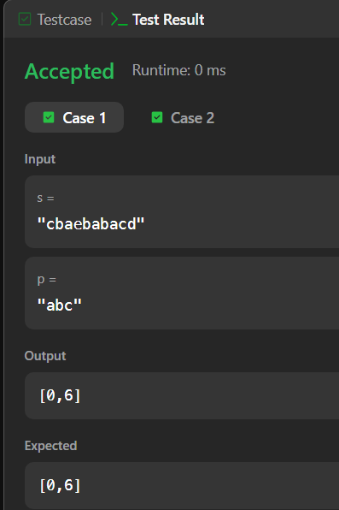

7. import java.util.*;
public class Solution {
private static boolean isPalindrome(String s, int l, int r) {
while (l < r) {
if (s.charAt(l) != s.charAt(r)) {
return false;
}
l++;
r--;
}
return true;
}
public static int palindromeIndex(String s) {
int left = 0, right = s.length() - 1;
while (left < right) {
if (s.charAt(left) == s.charAt(right)) {
left++;
right--;
} else {
if (isPalindrome(s, left + 1, right)) {
return left;
} if (isPalindrome(s, left, right - 1)) {
return right;
}
return -1;
}
}
return -1; // already palindrome
}
public static void main(String[] args) {
Scanner sc = new Scanner(System.in);
int q = sc.nextInt();
while (q-- > 0) {
String s = sc.next();
System.out.println(palindromeIndex(s));
}
sc.close();
}
}
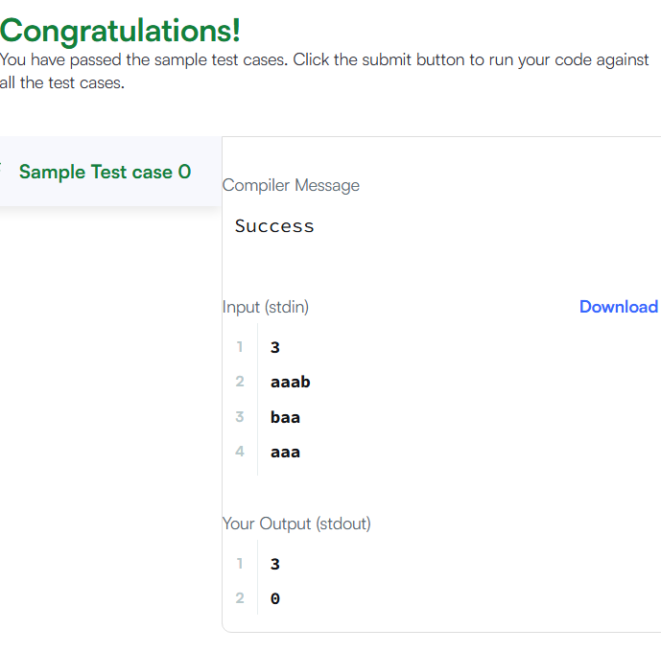

8. import java.util.*;
public class Solution {
public static int strStr(String haystack, String needle) {
return haystack.indexOf(needle);
}
public static void main(String[] args) {
Scanner sc = new Scanner(System.in);
String haystack = sc.next();
String needle = sc.next();
System.out.println(strStr(haystack, needle));
sc.close();
}
}
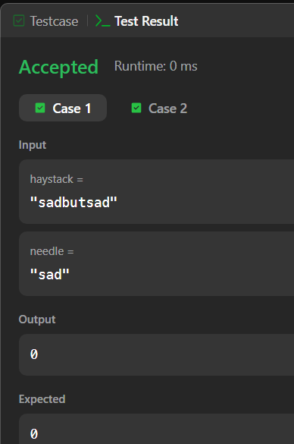

9. import java.util.*;
public class Solution {
public static String longestPalindrome(String s) {
if (s == null || s.length() < 1) return "";
int start = 0, end = 0;
for (int i = 0; i < s.length(); i++) {
int len1 = expandFromCenter(s, i, i); // odd length
int len2 = expandFromCenter(s, i, i + 1); // even length
int len = Math.max(len1, len2);
if (len > end - start) {
start = i - (len - 1) / 2;
end = i + len / 2;
}
}
return s.substring(start, end + 1);
}
private static int expandFromCenter(String s, int left, int right) {
while (left >= 0 && right < s.length() && s.charAt(left) == s.charAt(right)) {
left--;
right++;
}
return right - left - 1; // length of palindrome
}

public static void main(String[] args) {
Scanner sc = new Scanner(System.in);
String s = sc.next();
System.out.println(longestPalindrome(s));
sc.close();
}
}
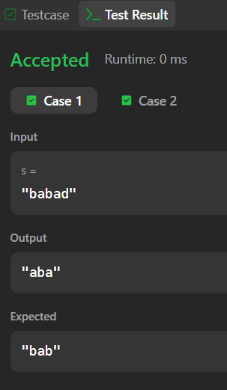

10. import java.util.*;
public class Solution {
private static int[] manacher(String s) {
int n = s.length();
char[] t = new char[2 * n + 3];
t[0] = '^';
for (int i = 0; i < n; i++) {
t[2 * i + 1] = '#';
t[2 * i + 2] = s.charAt(i);
}
t[2 * n + 1] = '#';
t[2 * n + 2] = '$';
int[] p = new int[t.length];
int center = 0, right = 0;
for (int i = 1; i < t.length - 1; i++) {
int mirror = 2 * center - i;
if (i < right) {
p[i] = Math.min(right - i, p[mirror]);
}
while (t[i + (1 + p[i])] == t[i - (1 + p[i])]) {
p[i]++;
}
if (i + p[i] > right) {
center = i;
right = i + p[i];
}
}
return p;
}
public static void main(String[] args) {
Scanner sc = new Scanner(System.in);
int n = sc.nextInt();
String s = sc.next();

String doubled = s + s;
int[] p = manacher(doubled);
for (int start = 0; start < n; start++) {
int end = start + n - 1;
int maxLen = 1;
for (int i = 1; i < p.length - 1; i++) {
int len = p[i];
int realCenter = (i - 1) / 2;
int left = realCenter - (len / 2);
int right = realCenter + (len / 2);
if (left >= start && right <= end) {
maxLen = Math.max(maxLen, len);
}
}
System.out.println(maxLen);
}
sc.close();
}
}
